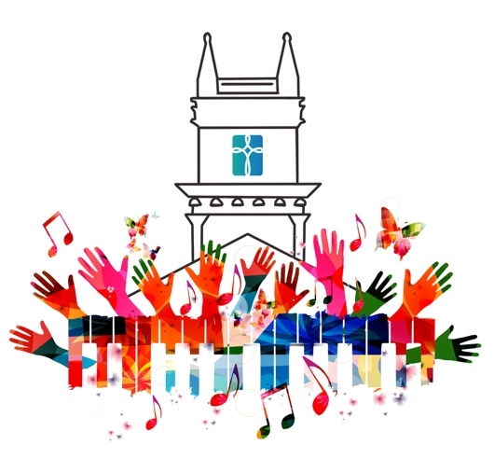

Love Unbound,
How Sweet the Sound!

A New Song for the Next Century

March 3, 2026

Dear Friends,

Whether you were with us in person on Sunday or are just now hearing this news,
we want you to know: something important and exciting is stirring at First Presbyterian Church of Yorktown, and we don't want you to miss it!

At our Annual Meeting on March 1, we officially announced Love Unbound, How Sweet the Sound! A New Song for the Next Century — a capital campaign that is,
at its heart, about who we are called to be for our community as we step into the next century of our ministry together.

WHY THIS MOMENT MATTERS

We live in a time of profound disconnection. The 2023 Surgeon General's report named social isolation a public health crisis, and for people of faith, it is a spiritual crisis as well. One in three American adults feels lonely every week. The places where community once formed naturally, where you could simply show up and belong, are quietly disappearing.

The church is not immune. When we began our ministry in the Presbytery of Hudson River in 2001, there were 108 congregations. Today there are 72, and at least a third of them are struggling to survive. We share this not to alarm you, but because we believe FPCY has always been a community that meets a moment with faithfulness and imagination, and this is our moment.

"Encourage one another in all wisdom, singing psalms and hymns and spiritual songs, with thankfulness in your hearts to God" (Colossians 3:16). That ancient invitation is exactly the spirit we are bringing to this campaign, and exactly the kind of community we believe FPCY is called to be.

OUR ANSWER: THE AGAPE MUSIC CENTER

Over the past year and a half, our leadership and congregation have been prayerfully discerning our vision for the future. We have reaffirmed who we are: a community called to Connect with God, One Another, and the World — to Feed Bodies and Spirits. And out of that discernment, something new has taken shape: the Agape Music Center.

This is not another church program. It is a ministry of presence — a welcoming "third place" where people of all ages and walks of life can come to connect, create, learn, and belong. Through music lessons, rehearsal space for local groups, sound healing, open mic nights, youth camps, concert series, and community partnerships, the Agape Music Center would carry the love of God well beyond our walls and well into the future.

Every program, at every level, for every age would carry the same message:
You are welcome here, exactly as you are.

Alongside the Music Center, we are caring for our beloved 35-year-old Austin pipe organ, which has faithfully led our worship through so many seasons and now needs restoration so it can continue to anchor our worship and fill this sanctuary for generations to come. In many ways, what the organ does for us in worship — gathering us, lifting us, connecting us to something larger than ourselves — is precisely the vision we hold for the Agape Music Center.

This is a moment of convergence, where our capital needs and our missional calling meet. We believe the future of FPCY depends on how faithfully we answer it together.

We invite you to read the attached Vision Brochure, which tells this story more fully and beautifully than any email can. Please take a few minutes to sit with it, share it with someone you love, and let it spark your own imagination for what FPCY can be.

WE WANT TO TALK WITH YOU

A vision this meaningful deserves more than an email. It deserves conversation, questions, and time together around a table.

We are hosting a series of intimate Coffee Chats in congregation members' homes and at the church between now and March 22. These are not fundraising events. They are gatherings for listening, learning, and sharing in the discernment together. Your presence at one of these conversations is itself a contribution to FPCY's future. The more voices in the room, the stronger the foundation we build.

Please sign up for a Coffee Chat today — it is the single most important thing you can do right now to be part of this journey.

Here's the full schedule:

Thursday, March 5 | 10:30 AM | First Presbyterian Church of Yorktown
Friday, March 6 | 2:00 PM | First Presbyterian Church of Yorktown
Saturday, March 7 | 7:00 PM | Home of Donna Gresh & Jeff Kephart (Cortlandt Manor)
Friday, March 13 | 7:00 PM | Home of Bill & Christie Herman (Yorktown)
Saturday, March 14 | 2:00 PM | Home of Karen Gerth (Shenorock)
Saturday, March 14 | 7:00 PM | Home of Connie Knapp & Anne Corey (Ossining)
Sunday, March 15 | 7:00 PM | Home of Beth & John Gruber (Cortlandt Manor)
Wednesday, March 18 | 12 Noon | Lunch Bunch & Hymn Sing, FPCY
Saturday, March 21 | 2:00 PM | Home of Charles & Ruth Barton (Mahopac)
Saturday, March 21 | 7:00 PM | Home of Jean & John Winget (Yorktown)

Sign up today at: https://forms.office.com/r/fjMbP3jW0R
(Or scan the QR code in the attached brochure.)

Spots fill quickly, so please don't wait. If none of these times work for you, reach out to us directly and we will find a way to connect.

A WORD OF GRATITUDE

Sunday's annual meeting was one of those mornings that reminds you why this community is so extraordinary. People received this vision with open hearts, and volunteers stepped forward on the spot to help carry it forward. That energy belongs to all of us — and to the future of this church.

If you weren't able to be there, we hope you feel it in these words. Because this is not our campaign. It is FPCY's. Every prayer offered, every question asked, every person who walks through the door of a coffee chat is helping to build something that will outlast all of us — something that will be here for the generations who walk through these doors long after we do.

We are being invited, together, to imagine more: more people finding community, more music filling more lives, more of God's boundless love let loose in our corner of the world. Come imagine it with us.

With hope and gratitude,

Kendra Ekelund, Chair
Love Unbound, How Sweet the Sound!
First Presbyterian Church of Yorktown

